- Overview

Price Change data is stored within two tables: pc_change (the header table) and pc_item (the detail table).

- Login Process

The login process should be the same as for User Administration.

- The “Price Change List” Window

After the supervisor successfully logs in, the program should display the “Price Change List” Window. This contains a list of all the active price changes. In this mode the title includes the phrase “(All SKUs)”.

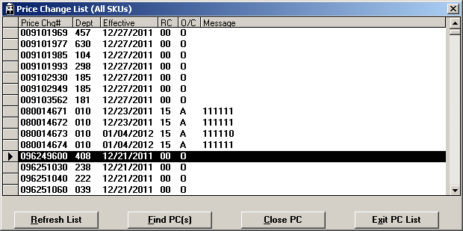

  - Database Details

select
pc_no,
pc_dept,
pc_effective_date,
pc_reason_cd,
pc_status,
pc_message
from pc_change
where pc_status in (“A”, “C”, “O”)
order by pc_no;

  - Buttons on “Price Change List” Window

The Buttons “Refresh List”, “Find PC(s)”, and “Exit PC List” should always remain active. However, the “Close PC” button will vary depending on the currently highlighted price change.

- If the status of the price change is “O” (Open), the button should be active and say “Close PC”.
- If the status is “C” (Closed), the button should be active and say “Open PC”.
- If the status is “A” (Store Initiated), the button should say “Close PC” but be disabled.

- Filtering Price Changes by SKU

In order to list only the price changes containing a specific SKU, the user should click on the “Find PC(s)” button. This will bring up a dialog box prompting for a SKU:

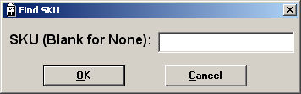

Since SKUs are numeric, this box will require a number between 1 and 13 digits. Once the SKU has been keyed, the program will repopulate the “Price Change List” window with a list of price changes containing this SKU. In this context the title includes the phrase “(SKU nnnnnn)”.

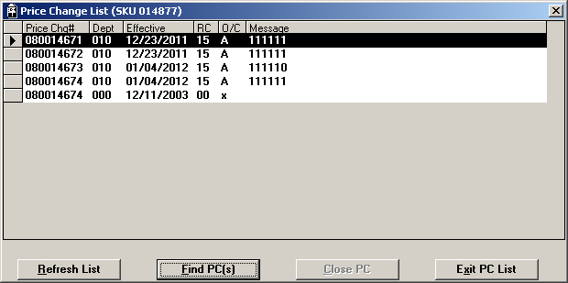

  - Database Details

Prior to executing the SQL statement, the program will need to take the keyed SKU, and split it into upper and lower pieces. The lower half should be the lowest 8 digits. The upper half should be everything greater than the lowest 8 digits. So if the keyed SKU is 111122223333, the upper half would be “1111”, and the lower half would be “22223333”. If the keyed SKU is 8 digits or less, the upper half would be “0”.

select
pc_no,
pc_dept,
pc_effective_date,
pc_reason_cd,
pc_status,
pc_message
from pc_change
where pc_status in (“A”, “C”, “O”)
and pc_no in (select i.pc_no from pc_item i
where pc_sku_overflow = <upper half of SKU>
and pc_sku = <lower half of SKU>
)
order by pc_no;

- Refreshing the List

If the user presses the “Refresh List” button, the program will use the non-SKU-filter version of the SQL to repopulate the window with the current list of price changes.

- Closing a Price Change

When the user presses the “Close PC” button, the program should confirm by asking the question “Close Price Change #nnnnnnnn?” If the user confirms, the program should close the price change header and detail records, then refresh the current screen (i.e., including the SKU filter if applicable), highlighting the record just modified.

This will also have the effect of changing the “Close PC” button to “Open PC”, since the highlighted row is now closed.

  - Database Details

begin work;

update pc_change set
pc_status = “C”,
pc_status_date = TODAY
where pc_no = <price-change number>;

update pc_item set
pc_status = “C”,
pc_status_date = TODAY
where pc_no = <price-change number>;

commit work;

- Reopening a Price Change

When the user presses the “Open PC” button, the program should confirm by asking the question “Reopen Price Change #nnnnnnnn?” If the user confirms, the program should reopen the price change header and detail records, then refresh the current screen (i.e., including the SKU filter if applicable), highlighting the record just modified.

This will also have the effect of changing the “Open PC” button to “Close PC”, since the highlighted row has now been reopened.

  - Database Details

begin work;

update pc_change set
pc_status = “O”,
pc_status_date = TODAY
where pc_no = <price-change number>;

update pc_item set
pc_status = “O”,
pc_status_date = TODAY
where pc_no = <price-change number>;

commit work;

- Editing Price Change Details

Within the Price Change List window, a record can be double-clicked. When this occurs, the program opens up a new window listing the price-change detail records:

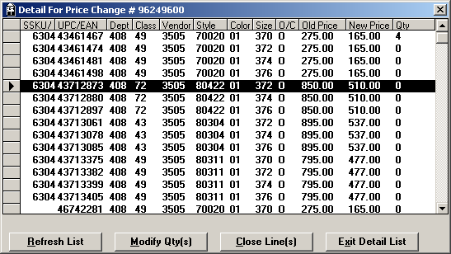

Note: The new application should join the two SKU components into a single column (see database details).

  - Database Details

select
(pc_sku_overflow * 100000000) + pc_sku ssku,
pc_dept,
pc_class,
pc_vendor,
pc_style,
pc_color,
pc_size,
pc_status,
pc_old_rtl,
pc_new_rtl,
pc_mrkd_qty,
pc_sku_overflow, (not displayed)
pc_sku (not displayed)
from pc_item
where pc_no = <Selected Price Change>
order by pc_dept, pc_class, pc_vendor, pc_style, pc_color, pc_size, ssku;

  - Record Selection

This window will allow multiple records to be selected at one time. Single-clicking one record will select it. Holding down the control key while clicking on another record will select it as well.

  - Buttons on “Price Change Detail” Window

The Buttons “Refresh List”, “Modify Qty”, and “Exit Detail List” should always remain active. However, the “Close Line(s)” button will vary depending on the currently highlighted SKUs.

- If the status of all the selected SKUs is “O” (Open), the button should be active and say “Close Line(s)”.
- If the status is “C” (Closed), the button should be active and say “Open Line(s)”.
- If more than SKU has been selected and the group contains both status values, the button should say “Close Line(s)” but be disabled

  - Clicking the “Refresh List” Button

When the user clicks on this button, the program will re-select the data from the database and display it again in the window. Any records that had been selected will be deselected.

  - Clicking the “Modify Qty” Button

In the current version of Launch Pad, the button is labeled “Modify Qty(s)”. It should be relabeled “Modify Qty”, since only one quantity can be modified at a time. As such, if the user has selected more than one record, the program should display a dialog box saying “Must Select A Single Record” instead of allowing the user to modify a quantity.

If only a single record has been selected, the program should display a dialog box where the user is allowed to key the quantity marked.

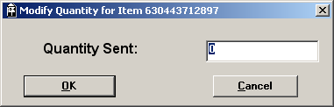

Note: The current program displays a box saying “Quantity Sent” instead of “Quantity Marked”.

  - Database Details

update pc_item set
pc_mrkd_qty = <keyed value>
where pc_no = <current price-change number>
and pc_sku_overflow = <current pc_sku_overflow value>
and pc_sku = <current pc_sku value>;

  - Clicking the “Close Line(s)” Button

When the user presses this button, the program must do the following:

- Display the message “Must Select At Least One Line” if no SKUs have been selected.
- If more than one SKU has been selected and the group contains both status values, the program should display the error message “Both Open and Closed Lines Have Been Selected” instead of allowing the user to go forward with the Close Line logic.
- If all the selected SKUs are currently open, the program should confirm with the message “Closed Selected Lines: Are You Sure?”
- If all the selected SKUs are currently closed, the program should confirm with the message “Open Selected Lines: Are You Sure?”

  - Database Details

To close lines:

update pc_item set
pc_status = “C”,
pc_status_date = TODAY
where pc_no = <selected price-change number>
and
(
(pc_sku_overflow = <pc_sku_overflow #1> and pc_sku = <pc_sku #1>)
or (pc_sku_overflow = <pc_sku_overflow #2> and pc_sku = <pc_sku #2>)
or (repeat for each selected SKU...)
)

To open lines:

update pc_item set
pc_status = “O”,
pc_status_date = TODAY
where pc_no = <selected price-change number>
and
(
(pc_sku_overflow = <pc_sku_overflow #1> and pc_sku = <pc_sku #1>)
or (pc_sku_overflow = <pc_sku_overflow #2> and pc_sku = <pc_sku #2>)
or (repeat for each selected SKU...)
)

